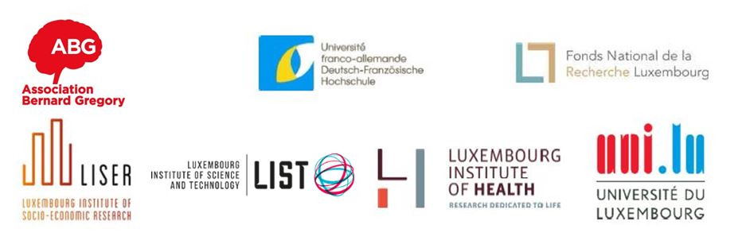
REGISTRATION FORM

Cross-border Workshop: PhD, what comes next?
Luxembourg, November 18th – 20th

Registration fees: 50€ (total costs of the training/participant: 500€)

For France and Germany (and any other cases)
For candidates from Luxembourg, please consult the specific registration call and calendar
Application deadline | July 14
Final selection and participation confirmation | July 20
Deadline for payment of fees | September 3

Fill in the registration form and submit it together with:
- your CV in English
- your cover letter in English: reasons why you want to take part in this workshop, your expectations and some information on your career goals. If you don’t have a precise idea of what you want to do next, please give us some information on your potential career orientation.

to the project coordinator of your institution:
- candidates from LIH: malou.fraiture@lih.lu
- candidates from LIST: julia.aguilar@list.lu
- candidates from the University of Luxembourg: anne.begue@uni.lu
- candidates from LISER: esther.zana-nau@liser.lu
- candidates working in France or Germany, or being unemployed (PhD graduation in the past 6 months at the time of the workshop), or back from an international mobility or facing a dual career development: berenice.kimpe@abg.asso.fr
- candidates funded by the FNR and not connected to any of those above institutions: marie-claude.marx@fnr.lu

YOUR PERSONAL DATA*
Last name
First name

City and country of residence
Phone number

E-mail address

YOUR PHD
University delivering your PhD

Research field

Expected end of your doctoral contract?
or
When did you get your PhD (mm/yy)?
Have you been supported by the Franco-German University (cotutelle or Franco-German doctoral college)? | yes no

For the eligibility of your application, please acknowledge the following:
□ I am aware that the registration fees will not be reimbursed in case of absence or in case of not informing the organization team 1 month before the start;
□ I commit myself to be present during the 3 days and to participate actively;
□ I am aware that 100% of presence and participation is required in order to collect the participation certificate.

* Your personal data will be known only to ABG and will not be divulged to third parties under any circumstances. According to the French data protection act (Law of the January 6th, 1978) and the GDPR regulation coming into force on 25 of May 2018, personal data are collected used within the strict framework of ABG missions. No personal data is transmitted or sold.

Date, signature

